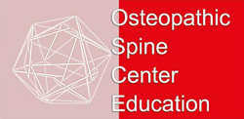
SYLABUS OF AXIAL SKELETON AND CRANIAL NERVES

- SKULL

Description of separeate bones of skull (frontal, parietal, occipital, sphenoidal bone, maxila, mandibula)
Skull- whole wiew and description
Orbit
Nasal cavity
Hard palate
Anterior cranial fossa- openings and topography
Medial cranial fossa- openings and contents, topography and of system of sinuses
Posterior cranial fossa- openings and contents, topography and of system of sinuses

- VERTEBRA COLUMN

Description of cervical vertebras
Description of thoracic vertebras
Description of lumbal vertebras
Description of sacral bone and pelvis
Articulation and ligaments of vertebra column
Topography of vertebral canal
Medulla spinalis and menings
Spinal nerves- introduction and schema, function

- PREPARATES

Basis cranii interna
Topography of menings in the skull
System of sinusis
Cranial nerves openings

Vertebral canal
Spinal cord and topography of menings

Brain
brain stem
cerebellum
cortex
frontal and horizontal slides of brain

